**DAILY ONLINE ACTIVITIES SUMMARY**

|  |  |  |  |  |  |  |  |
| --- | --- | --- | --- | --- | --- | --- | --- |
| **Date:** | **20-05-2020** | | | | **Name:** | **SURYA PRAKASH S** | |
| **Sem & Sec** | **6th Sem B sec** | | | | **USN:** | **4AL17CS101** | |
| **Online Test Summary** | | | | | | | |
| **Subject** | | **System Software and Computer Design** | | | | | |
| **Max. Marks** | | **30** | | **Score** | | **18** | |
| **Certification Course Summary** | | | | | | | |
| **Course** | **Python with Machine Learning** | | | | | | |
| **Certificate Provider** | | | **[Cognitiveclass.ai](http://Cognitiveclass.ai" \o "http://Cognitiveclass.ai)** | **Duration** | | | **12 hours** |
| **Coding Challenges** | | | | | | | |
| **Problem Statement: 1. Reverse of linked list. 2.Result Set Column 3.Exchange of values 4. Reverse of number** | | | | | | | |
| **Status: C**ompleted | | | | | | | |
| **Uploaded the report in Github** | | | | **Yes** | | | |
| **If yes Repository name** | | | | **[https://github.com/SPSSURYA/Online-Coding-And-Certification-Course](https://github.com/SPSSURYA/Online-Coding-And-Certification-Course" \o "https://github.com/SPSSURYA/Online-Coding-And-Certification-Course)** | | | |
| **Uploaded the report in slack** | | | | **Yes** | | | |

Online Test Details: (Attach the snapshot and briefly write the report for the same)

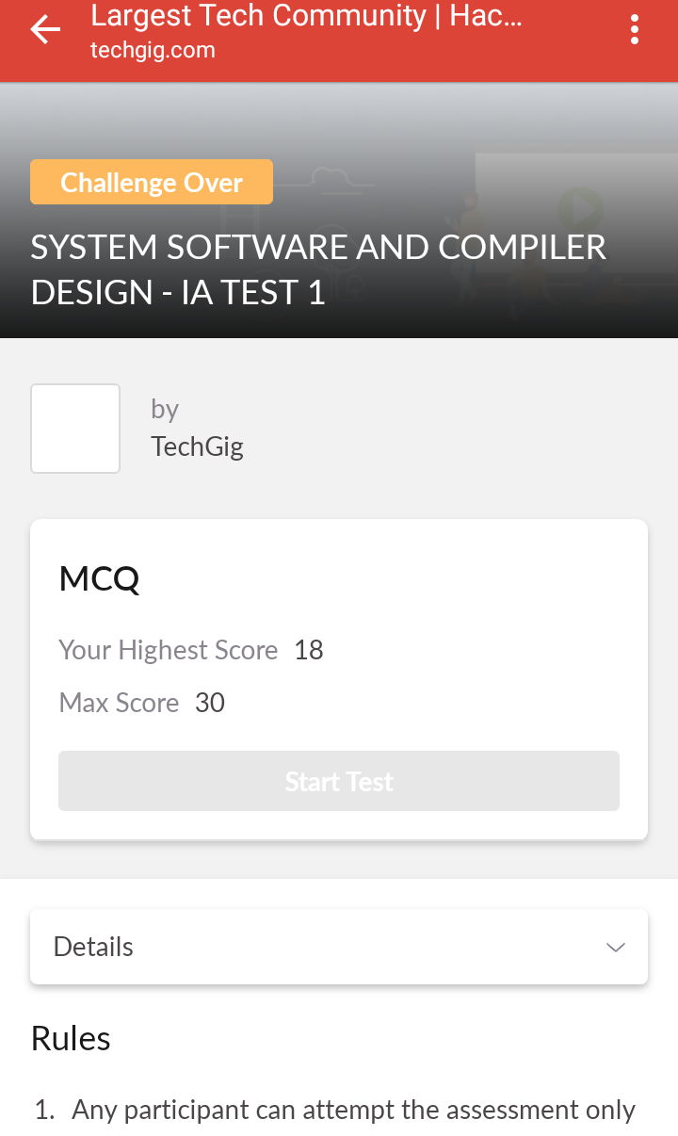

The test was held between 9:15 am to 9:55 am. It consisted of only 1 round and the total marks assigned was 30.The above snapshot is the output of my 1st IA test.

Certification Course Details: (Attach the snapshot and briefly write the report for the same)

**NAME : Surya Prakash S**

**USN : 4AL17CS101**

**COURSE NAME : Python with Machine Learning**

**LINK : <https://cognitiveclass.ai/courses>**

**Cognitive Class: ML0101ENv3**

**Org By : IBM**

**Start date : 20-05-2020**

**Duration : 12 hr**

**Progress on 20-05-2020**

* **Progress Report**

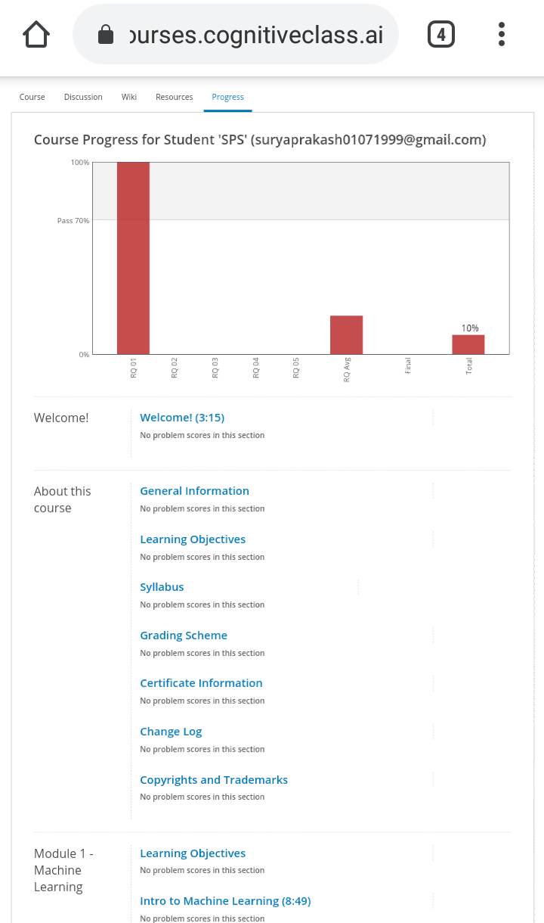

Coding Challenges Details: (Attach the snapshot and briefly write the report for the same)

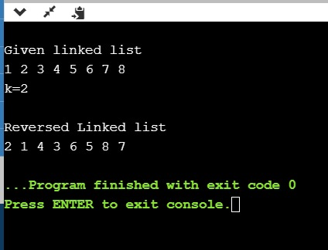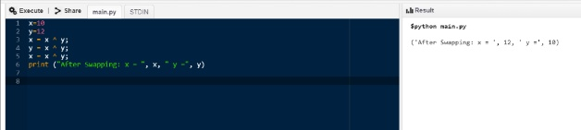

[https://github.com/SPSSURYA/Online-Coding-And-Certification-Course](https://github.com/SPSSURYA/Online-Coding-And-Certification-Course" \o "https://github.com/SPSSURYA/Online-Coding-And-Certification-Course)